Choose God & Sanctity or Self & Mediocrity
June 18, 2016
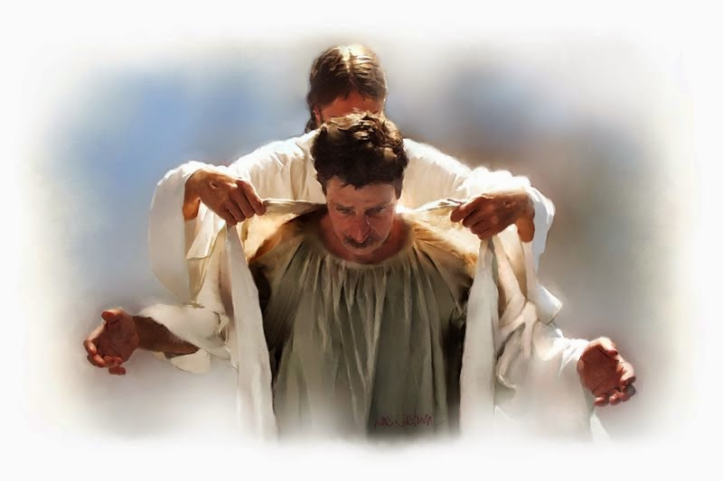
The Lord’s peace and endurance be with you all.

These times we are in right now are the most intense, because they are leading up to the destruction of the world’s system as we know it. The Lord is coming. He's coming back to rule and reign on the Earth. But before that can happen, there has to be a purification. And these are times for us to be purified, as well.

If we shrink back in fear, we will not gather fruit or grow in holiness. On the other hand, because these times are so intense there is an unprecedented opportunity to grow by leaps and bounds in authentic holiness.

Only through the pressing of the grape is the wine obtained. We are grapes in His vineyard being made into fine, aged wine fit for the King’s table. Yet if we shrink back, cover up and protect ourselves from God’s doings, we lose the honor to be used for the highest of His purposes. Many are called, few are chosen. And even less respond.

We can either choose God and sanctity, or choose ourselves and mediocrity.

I grew weary of the veneer over my life; compromises and lies hidden beneath this highly polished and thin wood. Very, very tired. I looked at my life and said, “This? This is all I am, an actor on the stage of life with a clever veneer that makes me acceptable in the eyes of man? Man, who is here today and gone tomorrow? Man, whose whims and fancies change with the wind?” The more I contemplated that, the more it smelled of corruption, and I wearied of myself.

There was more. I could feel it. There was more to life than being esteemed by men. There was something exciting beyond my self-imposed boundaries. And I could see it in the likes of Mother Theresa and other great souls that took tremendous chances by leaving their luke-warm lives behind, in order to pursue something beyond, way beyond themselves.

I saw in them the greatness I didn’t have and when I looked at my mediocre life, I wanted more. But was I willing to accept the challenge? Was I willing to forsake all to have what they had?

Slowly, the Lord Jesus coaxed me into letting go of the world even without my knowing it. And diving off the precipice of the unknown - only to land in His arms and discover the embrace my heart had longed for, the embrace my endless ambition and striving to impress the world had sought. But the kind of love I longed for could never be found in the world. I didn't know that, until the Lord loved me and made that love obvious to me.

One day, the veneer came off, and the boil that was my compromised life was lanced. It is written that there is nothing hidden that will not be exposed. And I felt exposed, helpless, and totally ready to find the true meaning to my life. I had spent years building up my veneer with accomplishments: a $500-a-day rate as a photographer in the 70’s, magazine articles hailing my nature photography, lavish expense accounts and invitations from the influential in Washington.

I am convinced that each of us is given at least a few invitations to leave facades and mediocrity behind, to embrace Truth, and to stand in the light of His presence. That stale life I was living came to an end one day and I saw my nakedness before the Lord. I was ready. I was sick of my superficial and selfish life, sick of all the lies and posturing I put on to justify myself to others. I wanted to be holy. Holy before God, not man.

Because of past abuses from important people in my life and ridicule, a steel wall had been erected not only between me and others, but also between God and I. I didn’t recognize my worth in the Lord’s shed Blood on Calvary, rather I judged by worldly standards and held that up for the world to see. But God saw right through me. And His love for my precious soul and His desire to see me really living for Him, from the inside out, motivated Him to make me unsatisfied and restless with my life. I longed to fulfill my purpose, but had held on so tightly to my concept of self-worth, there was no room for me to discover God’s purpose. I was blocking it out of the fear of being vulnerable to ridicule and vulnerable to failure. I had determined I would never be a nothing again.

I was not ready for the assignment and mission of my life. I was totally unprepared to face God, let alone the calamity that is promised for these end times. I was looking for my worth in corruptible flesh and not finding it. But before I could let go of that, I had to face my failures and acknowledge I was not living up to what God created me to be. Only He could convince me of that, and thankfully, He did.

At this point, Jesus began speaking, “Precious souls, if you are holding up a veneer for the world to see, you are defeating the entire purpose of your life. I created you to shine and be a light to the nations, but you will never fulfill your purpose if your light is buried beneath a stack of worldly laurels. I need to get down deep, down to the quick of your souls where I can build a foundation of holiness. On rock, not the shifting sands of this world that will be stripped from you at death.

"All that is of the world will come off and only who you are before Me and before Heaven will remain. This is your eternity. Heaven is a very different place than Earth; what you could get away with on the Earth is starkly obvious to those in Heaven. Only truth and the precious worth of your soul are seen and honored.

"I died for you. Do you understand? The Blood of your God was sacrificed on the altar of Justice to cleanse you from your sins. Nothing you could ever do or accumulate in this world - nothing - could ever compare with the price of My Blood.

"I did this, because your naked, raw soul is precious and adorable to Me. Everything from the world you pile on to that, to give yourself value is defiling and robbing you of My light through your being. To keep the world’s laurels, you must live by the world’s value system. The world is without spiritual light. The world is created matter and lacks enduring significance. It is not the essence of life, but rather the essence of matter, which is in a constant state of flux and deterioration.

"So, when you live your life by the world’s standards you are walking in darkness, snuffing out your light and reflecting that which is deteriorating and bound for death. Oh, highly precious souls, imprints of the God Who created you, your worth is immeasurable! And nothing short of My death on the Cross can atone for your wayward ways and bring you back into the Light of eternity.

"What is needed from you is to walk in nakedness before man and God, that your light might shine. When you discover My love for you and realize who you truly are in My presence, your value system changes immediately. What was once highly prized is seen for what it is: unclean rags hanging from your body. Like a leper, the contamination of the world smothers the light given you at conception.

"Open yourself to My Love. I am not like any man you have ever known; all are corrupt and lacking in authentic love. When I love you I do not mix My love with earthly values. I look at the beauty and uniqueness of My Father, whose substance formed you. And I long to redeem you from among this decaying world and have you in Heaven with Me for eternity.

"You have nothing to fear and nothing to hide from Me. Come to Me naked and I will clothe you in My righteousness."

